Forecasting Methods Homework Report for Question-1

a-)
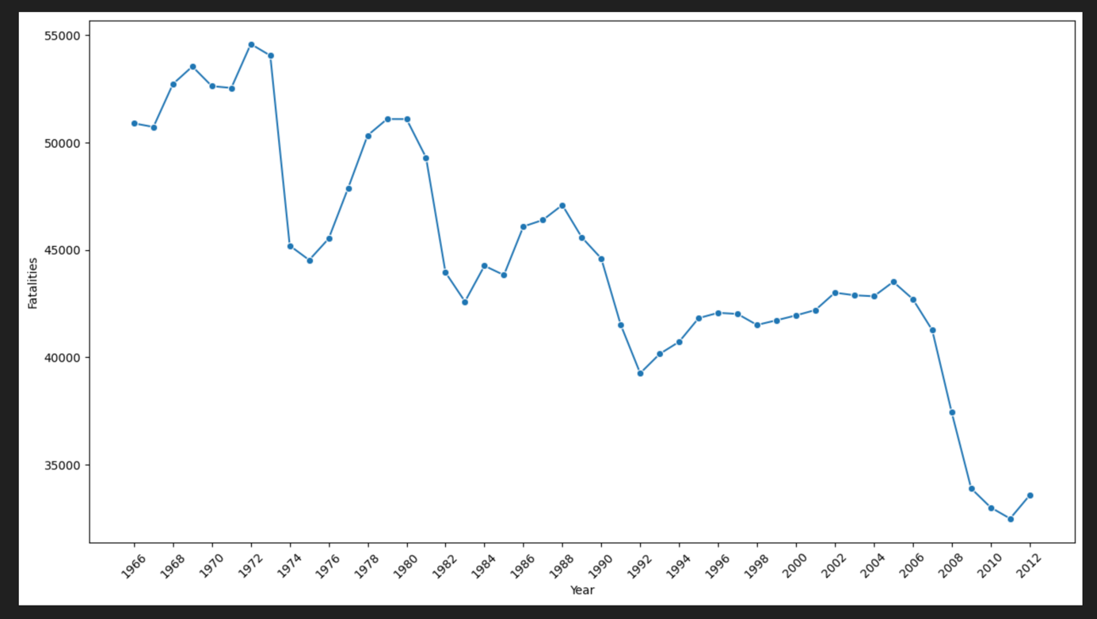 It has a strong negative trend. It means that it is constantly changing, meaning that its trend is strong. Therefore, this series has violated the stationarity.

b-)
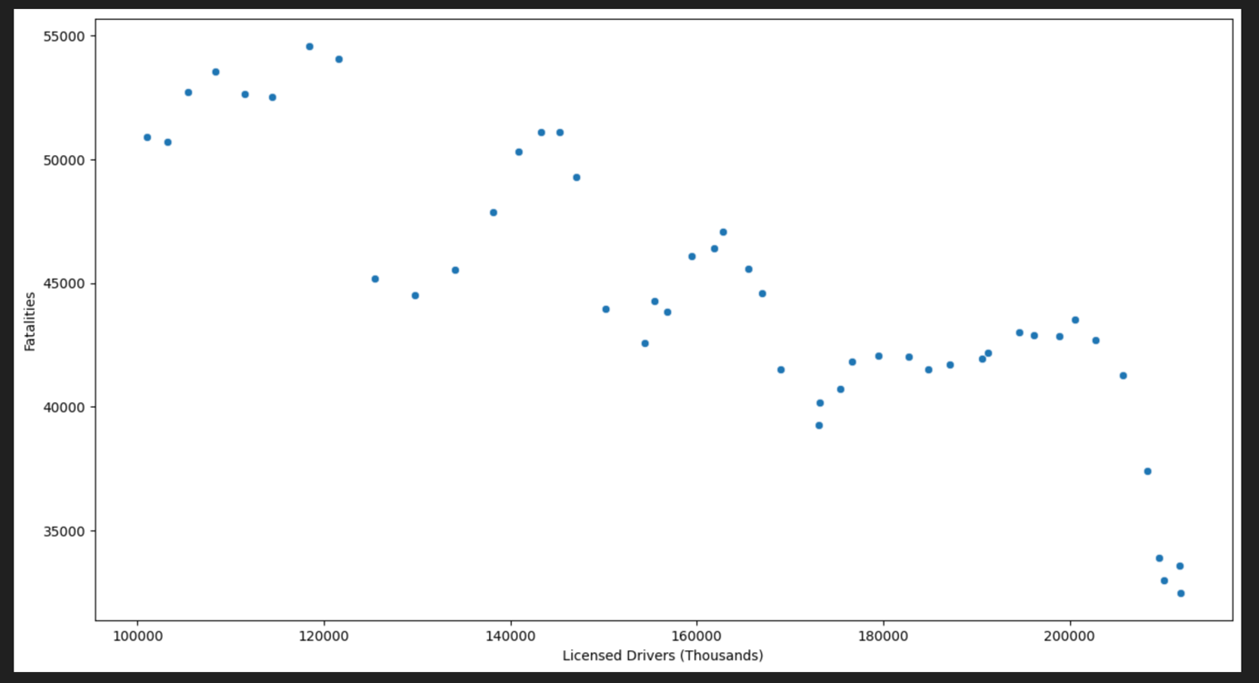
When looking at the general trend of the graph, a negative correlation is observed. The decrease in the number of fatalities as the number of licensed drivers increases indicates uncertainty and dispersion. The data is not concentrated at a single point or follows a straight line. At this point, linear regression may be insufficient to capture this relationship because the (X,Y) pair may not be linear.

c-)
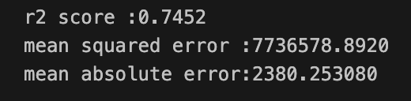
A high r2 score indicates a high explanatory power for the model.
MAE indicates an average error of 2380 units in the predictions. Even a high R2 score indicates that our predictions have a high margin of error.
MSE indicates that outliers tend to bias the model more.

d-)
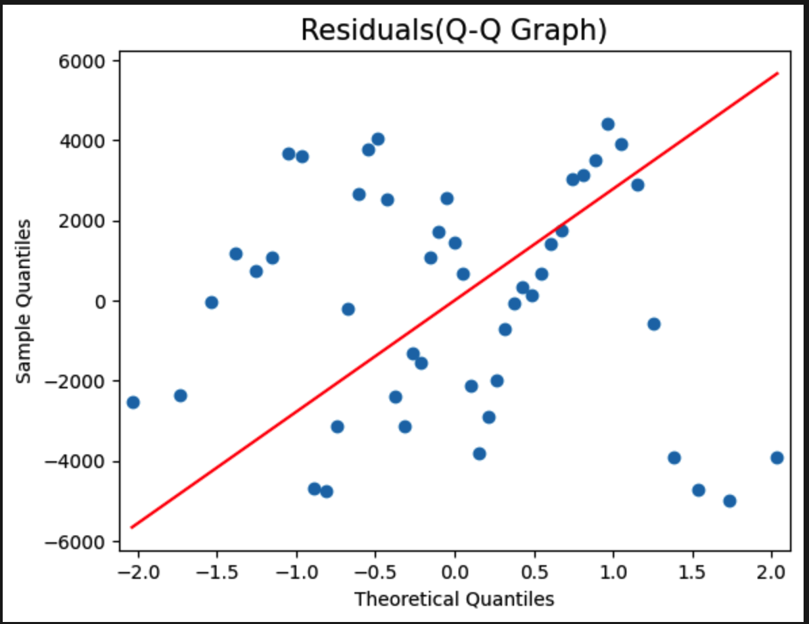

In the middle of the graph, the points roughly follow the line, but at the extreme points of the graph, the points deviate significantly from the line. This observation indicates that the distribution is not a normal distribution. It violates the assumption of normality.

e-)
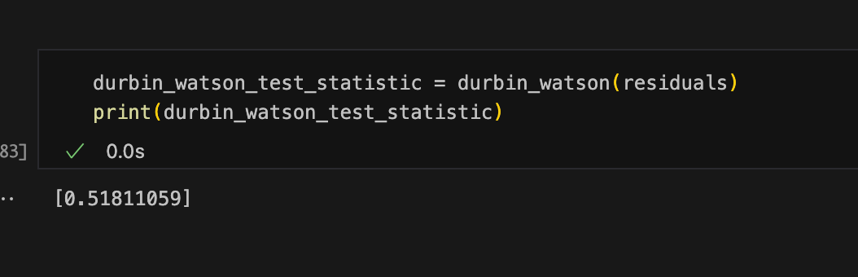

0.51 is very close to 0, which is strong evidence of positive autocorrelation. Positive autocorrelation means that our model does not accurately capture the trend over time.
Using simple linear regression is not recommended because it violates the assumption of independence of residuals.
Since we need to use a model that respects the assumption of independence, a time series model would be more appropriate.

